Problem Specification - Requirements

Tuesday, June 18, 2013 2:41 PM

Problem Specification

Describe in clear non-technical language what the project will attempt to do. Explain any terms that may be unknown to a reader unfamiliar with the specific subject area of the proposal. Focus on what the project will accomplish, that is, on the functionalities that it will support. The problem specification should be one to two pages in length.

Product overview

Planit is an application tool that is used for taking an individual's responsibilities and helps users accomplish them. This is done from a web interface by breaking down cumbersome tasks into more manageable pieces and use of visual metrics in conjunction with scheduling to help them be more productive.

Increment 1 Requirements:

The product shall have a web interface that shall include:

1. Layout
   1. Home
   2. View
      * 1. Tree view
        2. Outline view
        3. Calendar (Schedule View)
        4. Task View
   3. Ribbons Top

Bottom

* 1. About us
     + 1. Mission Statement / Our Team
       2. Blog
  2. Contact Us

a. Contact/Feedback/Report A Problem

* 1. Help
     + 1. Try it
       2. FAQ
  2. Social
  3. Terms and conditions
  4. Privacy

1. Functionality
   1. Home
   2. View
      1. Tree view
      2. Outline view
      3. Calendar (Schedule View)
      4. Task View
2. Ribbons Top

Bottom

1. About us
   1. Mission Statement / Our Team
   2. Blog
2. Contact Us

a. Contact/Feedback/Report A Problem

1. Help
   1. Try it
   2. FAQ
2. Social
3. Terms and conditions
4. Privacy

1. Home

The Home view is the portal to explore

The product shall have a web interface that shall include the following views: Home, Views (Tree View, Outline View, Calendar or Schedule View and Tasks View).

Top View - Welcome

In the Home View there shall be a Welcoming Introduction, Links to Log In directly or through Facebook, a link if the username or password has been forgotten, and a sign up. This initial page will have a fold where the top portions is the above and the Explore Link, links to the bottom portion to the sign up and either a quick introduction or video snippet introducing and giving a brief overview of Plan*it.*

Login

The Log In area of the Home View will allow for logging in directly or through a social network like

Facebook. There will be a link under the Direct Log In area in case the user forgets their Username or Password that links to help in accessing that information. There shall be a Log In button that submits the Username and Password, a Join Now button that links to the view below the fold where a potential user can sign up and a button to log in through Facebook. There shall be a Help link for directions on using the Log In, Forgotten Username or Password, and FAQ’s about Planit.

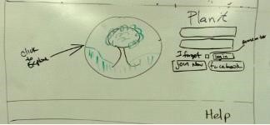

Bottom View - Explore

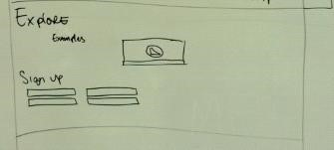

1. Views

To help the user plan their task or project, there shall be a Tree View, an Outline View, a Calendar/Schedule View, and a Task View for adding, removing, updating, viewing the progress of the task or project. There shall be a 1/8 context left panel in each of the Views which will display a condensed version of secondary views.

Each view shall be a primary

* 1. Tree view

The Tree View shall have a visual representation of the task or project with the 1/8 context based left panel that toggles between Outline View or Task View when in Tree View.

Visual overview of the user's projects and tasks

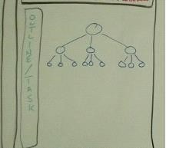

* 1. Outline view

The Outline View shall have an outline representation of the task or project with the 1/8 context based left panel that displays Tasks View.

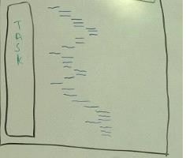

* 1. Calendar (Schedule View)

The Calendar View shall have a calendar representation of the task or project with the 1/8 context based left panel that toggles between the Outline View and Task View.

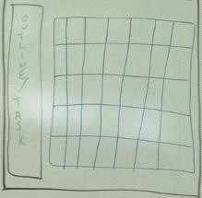

* 1. Task

The Task View shall have a chronological list of tasks within the next few days with the 1/8 context based left panel that displays the Outline View.

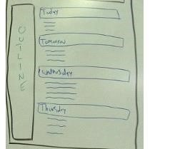

* 1. Context based left panel

i. 1/8 view

1. Ribbons

There shall be a consistent Top Ribbon with the following links: Tree, Outline, Tasks, Schedule, Analytics, Notifications, and 'User Settings' containing Settings and log out.

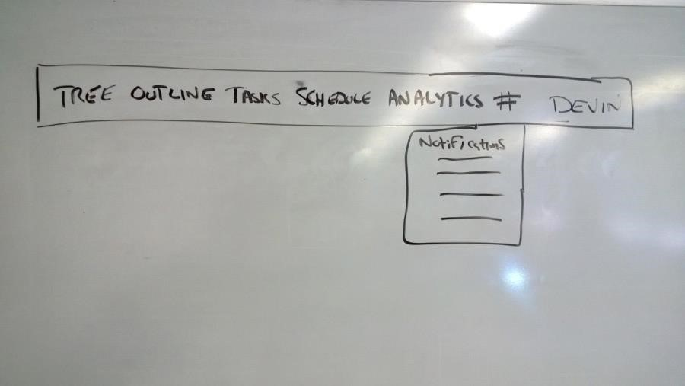

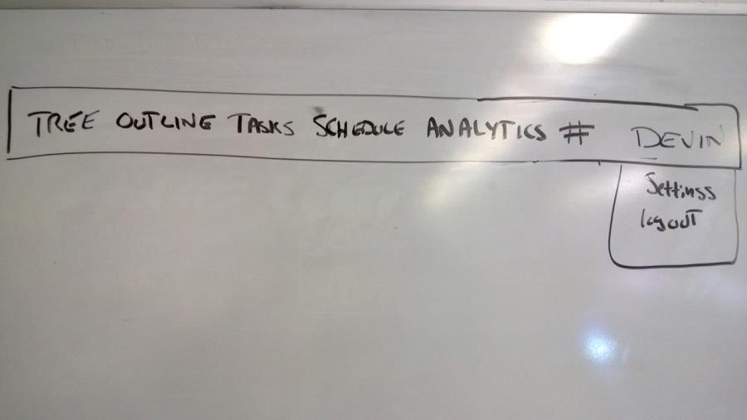

There shall be a consistent Bottom Ribbon with the following Headings: About Us, Contact Us, Help and Social. Under the heading About Us there shall be links to: Mission Statement, Our Team and Blog. Under the heading Contact Us there shall be links to: Contact, Feedback, and Report a Problem. Under the heading Help there shall be links to: Try it (How To Use) and FAQ's. Under the heading Social there shall be links to

Facebook and Twitter. Below the primary headings there shall be links to Terms and Conditions, and Privacy.

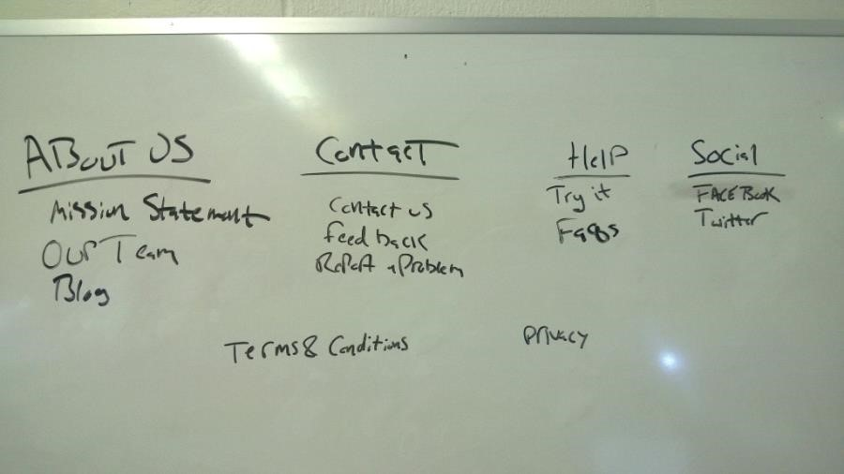

1. About us
   1. Mission Statement / Our Team

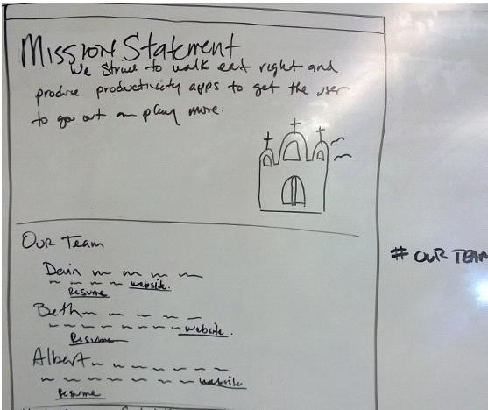

There shall be an *About Us* page that consists of two page displays; *Mission Statement*, and *Our Team* below the fold. *Mission Statement* shall contain our mission statement. *Our Team shall consist of the three team members short profiles.*

* 1. Blog

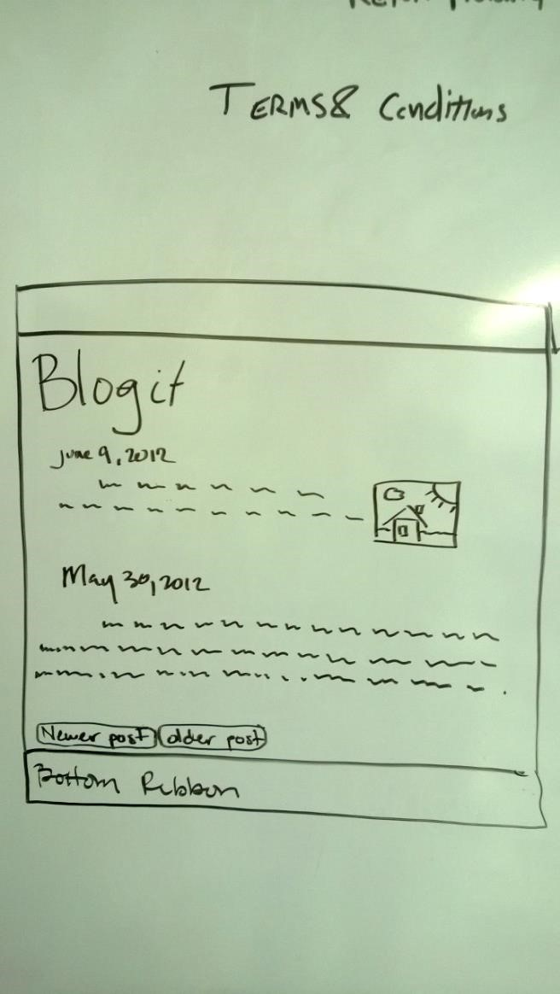

1. Contact Us
   1. Contact / Feedback / Report a Problem

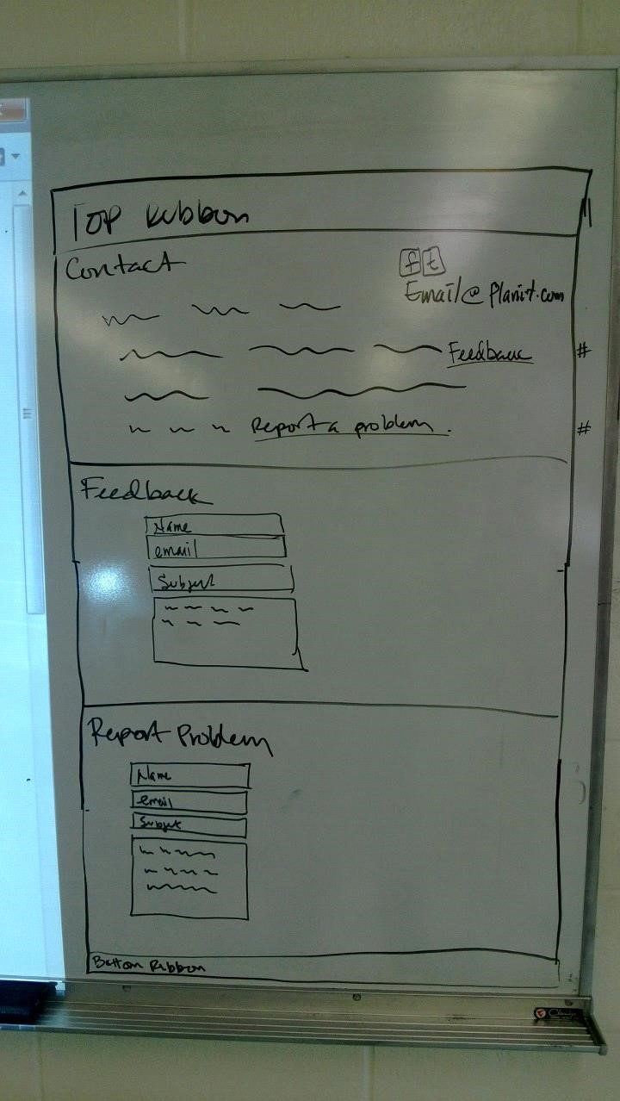

There shall be a page with the ability to contact us, send feedback, and report a problem. The three will be separated by a fold in the page and linkable from the bottom ribbon.

1. Help
2. Try It

There shall be an easy to follow tutorial that gets the user started with Plan it.

1. FAQ

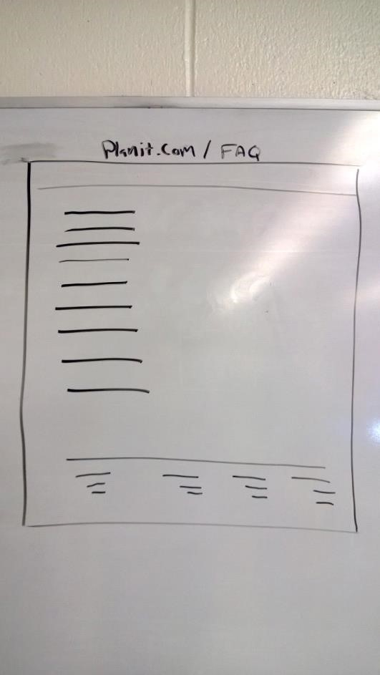

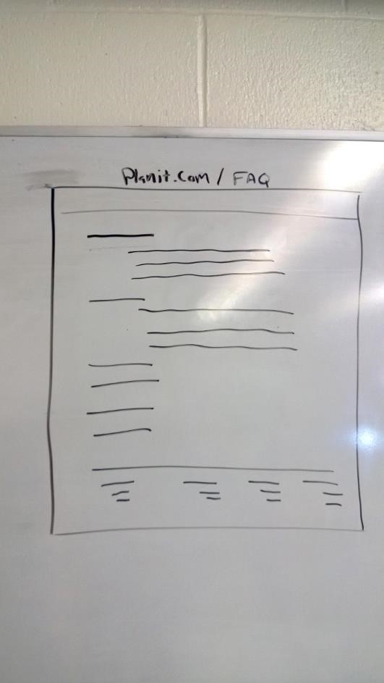

There shall be a list of frequently asked questions with answers for the user to the most commonly asked questions.

1. Social

There shall be links to our social networking pages on Facebook or Twitter.

1. Terms and conditions

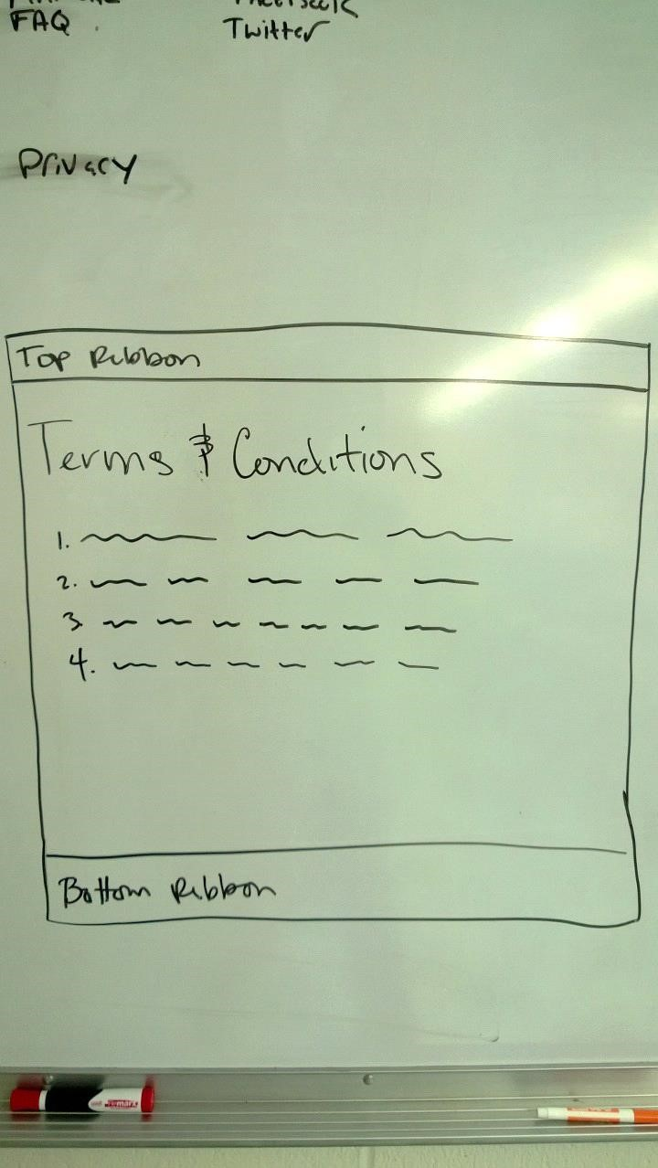

Terms and Conditions mumbo jumbo to be determined.

1. Privacy

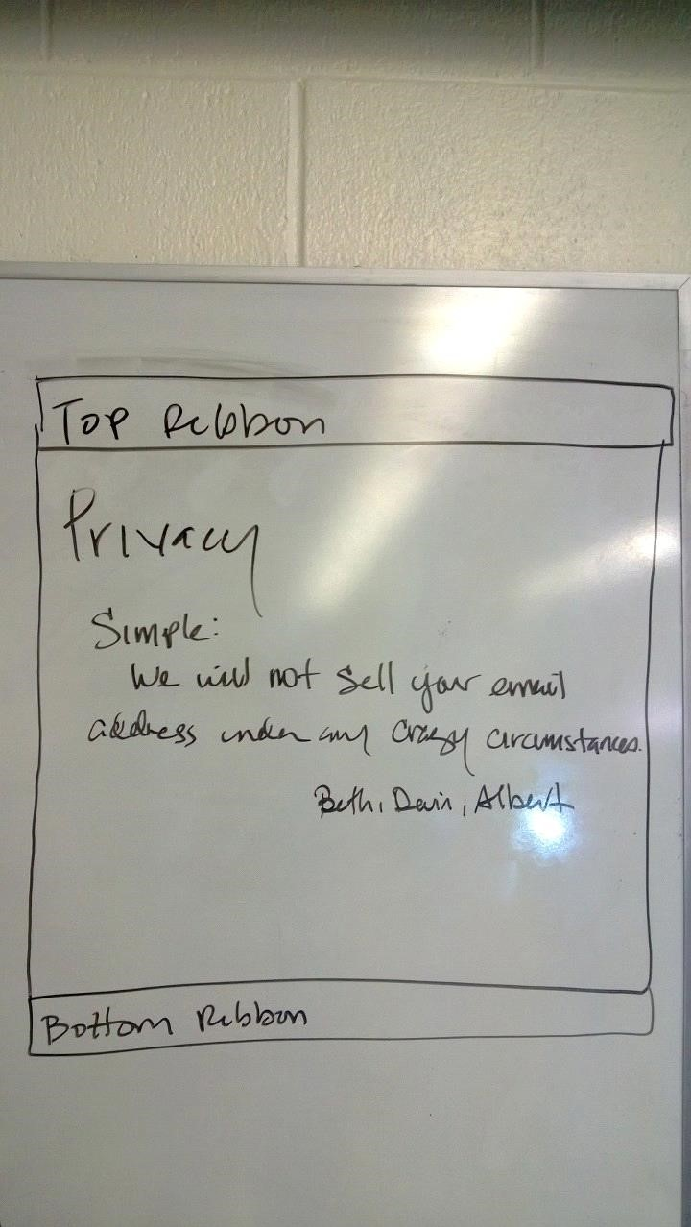

Privacy mumbo jumbo to be determined.

2. Functionality

Tasks

For a new task, the user will define the name, due date, effort, priority, estimated duration, cumulative time, notes, and reminder settings.

Due date : There shall be functionality that allows the user to enter the due date of the task. The required input shall be date and time. If no due date is entered then the user will be required to manually enter due dates at later time.

Effort: There shall be functionality that allows the user to set the effort of the task, including high, medium, and low. If none is given by the user then it will default to medium.

Priority: There shall be functionality that allows the user to set the priority of the tasks, including high, medium, and low.

Planit Points:

Points will be calculated by super secret algorithm, our secret sauce, that takes effort, priority and estimated duration to tell the user if they are crazy.

Estimated duration: There shall be functionality that allows the user to enter the estimated total time for the task. If none is given by the user, it will default to null.

Reminder settings: There shall be functionality that allows the user to set the reminder date and time. If no date is set, it will default to null.

Cumulative Time: When a task is initiated then the time is zero. As time progresses, Cumulative Time increments to give a realistic view of the time invested in the task.

Notes: Blank area for notes. Will default to null.

Box it (time boxing) - Set the time for the task

There shall be functionality that allows the user to allocate time segments to tasks.

**Increment 2 Requirements:**

Analytics Page

Millipede View - see below

If a lowest irreducible task is large in effort….then it should be broken down into smaller effort "sessions" Awareness of tasks "not making progress" relative to other comparable tasks or child processes 2 mobile platform

2 Suggestion Trees based on a database (Drop Down)

2 Break Down Warning

2 Sharing Tasks as in Pay it forward (Social Networking) Profile Page

2 Plug-ins for different categories/tasks

2 Add Whimsy

2 Visual Metrics Timer

Progress

Documentation (Devin's Word for Attachment of photos)

Estimated time Budget vs Actual Time Budget

Running daily average Productivity

Using Genomics and gamification to will access all of your productivity and give the user analytics to their productivity.

2 Separate Admin Control Panel

2 Using social media positively to reinforce productivity

Who can see what Permissions

2 Ability to snooze reminders

1. Suggested Time Budget
2. Dollar Budget ( It's a cost thing )

Intake questions: to better understand a person's most efficient times during the day